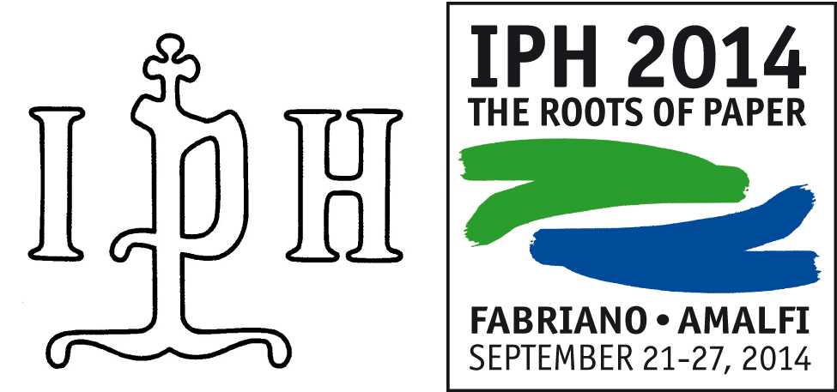

Partecipants | Coming from | Speaker | IPH Member
Albro, Silvia | USA, Washington | S | YES
Balachenkova, Alexandra | Russia, San Pietroburgo | S
Biddle, Michaelle | Middletown, USA | S | YES
Bustarret, Claire | Paris, France | S | YES
Carreira, Maria | Portugal | S
D'Antuono Andrea | Amalfi, Italy | S
De Aviles Augusto Fernandez | Madrid, Spain | S
Diaz, Maria Dolores Miranda | Barcellona, Spain | S
Dufournier, Benoit | Paris, France | S
Enami,Kazuyuki, | Otsu, Japan | S | YES
Engel, Patricia | Langenlois, Austria | S | YES
Fakhriati | Jakarta, Indonesia | S
Fucini, Alessandra | Rome, Italy | S
Gendron, Celine | Montreal, Canada | S | YES
Helman-Wazny, Agnieszka |  | (co-author)
Hidalgo Brinquis, Maria del Carmen | Madrid, Spain | S | YES
Laroque Claude | Francia | S | YES
Marques, Antonio Jorge | Lisbon, Portugal | S
Misiti, Maria Cristina | Rome, Italy | S | YES
Rischel, Anna-Grethe | Denmark | S | YES
Schmidt, Frieder | Lipsia, Germany | S | YES
Scianna, Nicolangelo | Forlì, Italy | S | YES
Shishkova, Elena | Russia | (co-author)
Sistach, Maria Carmen | Spagna, Barcellona | S | YES
Stieglecker, Maria | Austria, Vienna | S | YES
Taiani, Angelo | Amalfi, Italia (IPH) | S | YES
Teodonio, Lorenzo | Rome, Italy | S
Wenger, Emanuel | Wien, Austria, | S | YES
Partecipant non speakers

Albro, Thomas , | Washington, USA
Baldinger, Esra | Laakirchen, Austria |  | YES
Bedinsky, Maria | Gatineau, Canada
Brunetti, Silvia | Paris, France |  | YES
Carvalho, Ana Paula | Portugal
Christ Magdalene | Germany |  | YES
Cuppen, Martin | Gennen, Nederland |  | YES
De La Pena, Clara | London, Great Britain
Dirda, Marian | Washington, USA |  | YES
Dirda, Michael | Washington, USA
Duval, Tatyana | Ithaca, USA
Enshaian, Marie-Christine | Francia
Fairbanks Harris, Theresa | Hamden Town, USA
Greve, Kari | Oslo, Norway |  | YES
Hincelin, Emanuelle | France
Ishizuka, Harumichi | Japan
Ishizuka, Tsuneko | Japan
Keddies, Jutta
Kehl, Bruno | Malmedy, Belgium |  | YES
Mandl Gisella | Swiss |  | YES
Mariani, Franco | Fabriano, Italy |  | YES
Marijore, Shelley |  |  | YES
Nielsen, Ingelise | Copenhagen, Denmark |  | YES
Neuhebser Hanns Peter att. Christ Magdalen | Germany
Peaucelle, Denis | France |  | YES
Samson, Genevieve
Sandri Fernando | Brazil
Santos, Maria José | Esmoriz, Portugal |  | YES
Telford, Josette | Pontlevoy, France
Telford, Roy | Pontlevoy, France
Udina, Antonio Maria
Oliveira, Manuel | Spain
Fernandes, Valente | Spain

Partecipants: 62
Speakers: 28
Speakers/IPH Members: 16
IPH Members (Total): 29

2014, September, 14

